Centers

TC_076

Ensure the dropdown lists for State, City, and Center function properly

1. Tap on the State dropdown and select "Rajasthan"  
2. Tap on the City dropdown and select "Jodhpur"  
3. Tap on the Center dropdown and select "Edu World School"  
4. Click the Submit button

Working as expected

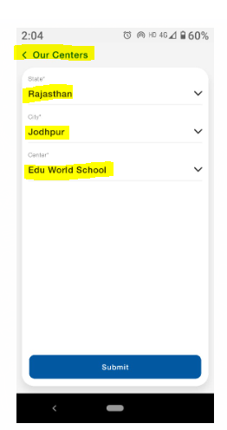

TC_077

Ensure the **Submit** button remains disabled until all fields are selected

1. Open the form  
   2. Do not select any values  
   3. Check if the Submit button is disabled  
   4. Select values for State, City, and Center  
   5. Verify if the Submit button is enabled

The Submit button is showing enabled both before and after all dropdowns

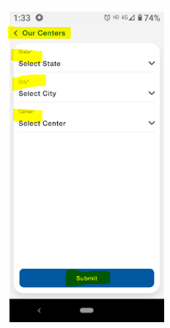

TC_078

Ensure each dropdown has a default placeholder value

1. Open the form  
2. Check if the State dropdown has a placeholder (e.g., "Select State")  
3. Check if the City dropdown has a placeholder (e.g., "Select City")  
4. Check if the Center dropdown has a placeholder (e.g., "Select Center")

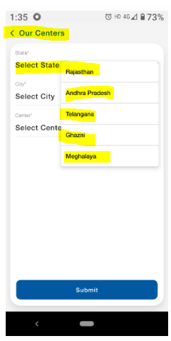

TC_079

Ensure selecting a **State** updates the list of available **Cities**

1. Select Rajasthan as the state  
2. Open the City dropdown  
3. Verify that only cities from Rajasthan (e.g., Jodhpur) are displayed

Working as expected

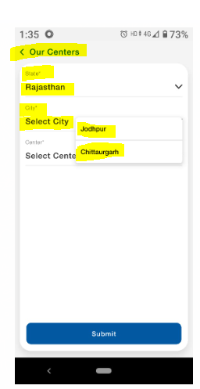

TC_080

Ensure selecting a **City** updates the list of available **Centers**

1. Select Jodhpur as the city  
2. Open the Center dropdown  
3. Verify that only centers in Jodhpur (e.g., Edu World School) are displayed

Working as expected

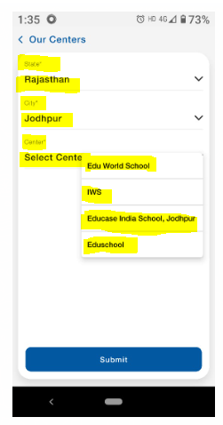

TC_081

Ensure an error message appears if the user tries to submit without selecting values

1. Open the form  
2. Click the Submit button without selecting any values

The system is displaying an error message like "Please fill mandatory details!."

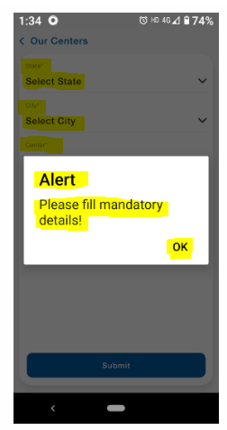

TC_082

Ensure the email, mobile number, and alternative mobile number are correctly displayed

1. Open the Contact Us page  
2. Verify that the email address is displayed correctly  
3. Verify that the mobile number and alternative mobile number are correct

mobile number and alternative mobile number are same

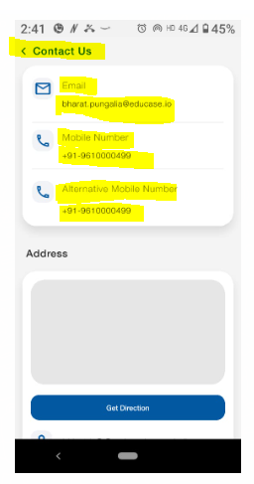

TC_083

Ensure clicking on the email address opens the default email app

1. Click on the email address  
2. Check if the default email app (Gmail, Outlook, etc.) opens with a new email draft

Working as expected

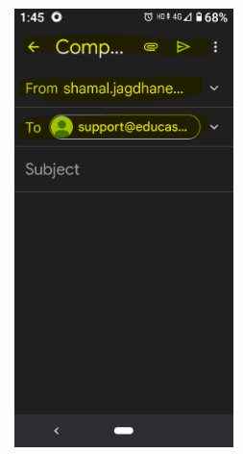

TC_084

Ensure clicking the **mobile number** opens the dialer app

1. Click on the mobile number  
2. Verify if the phone dialer opens with the number prefilled

phone dialer is not opening with the number prefilled

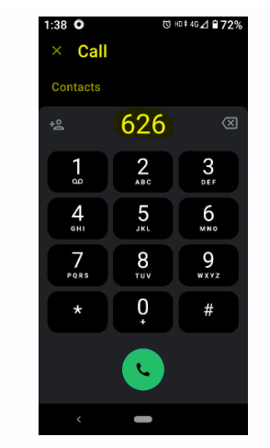

TC_085

Ensure clicking **Get Direction** opens the maps application

1. Click on the Get Direction button  
2. Verify that Google Maps (or another maps app) opens with the correct location

The maps application is not opening with the correct location

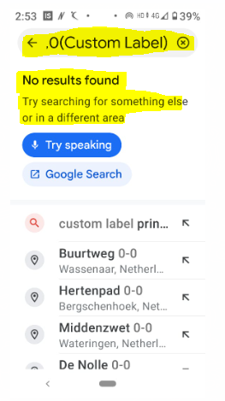

TC_086

Ensure the **Contact Us** page adapts well on different screen sizes

1. Open the Contact Us page on a mobile device  
2. Open the same page on a tablet  
3. Open the same page on a desktop browser  
4. Verify that all elements are properly aligned

The page should display properly across all screen sizes

TC_087

Ensure the page handles internet disconnection gracefully

1. Turn off internet connectivity  
2. Open the Contact Us page  
3. Verify whether an error message is displayed

Working as expected

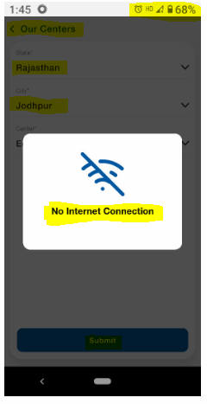

TC_088

Ensure long email addresses do not break the UI

1. Enter an extremely long email address in the backend (e.g., "verylongemailaddress123456789@reallylongdomain.com")  
2. Open the Contact Us page and check how the email is displayed

The email should be properly displayed (e.g., wrapped or truncated with "...")

TC_089

Ensure the **mobile number** and **alternative mobile number** are not the same

1. Check if the primary and alternative mobile numbers are identical  
2. If they are the same, verify if a validation error appears

mobile number and alternative mobile number are same

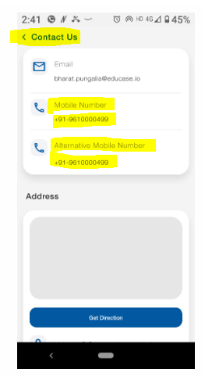

TC_090

Ensure the **Get Direction** button handles missing location data properly

1. Remove the location data from the backend  
2. Open the Contact Us page  
3. Click the Get Direction button

The system should display an appropriate error message (e.g., "Location data unavailable")